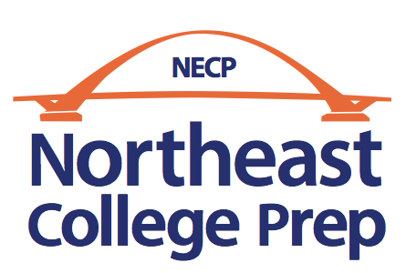

2019-20 Annual Report and World’s Best Workforce
Report

Table of Contents

I. Mission, Vision, and Core Convictions | 3
II. Student Enrollment, Attendance and Demographics | 4
III. Student Attrition | 9
IV. Governance and Management/Administration | 9
V. Board Member Training | 10
VI. Staffing | 12
VII. School Director Professional Development Plan | 13
VIII. Finances | 13
IX. Academic Performance | 14
X. Professional Development | 14
XI. Parent Satisfaction | 16
XII. Innovative Practices | 19
XIII. Major Accomplishments in 2019-20 and Future Plans  XIV. 2019-20 Continuous Improvement Plan | 20  22
XV. Authorizer Contact Information | 23

I. Mission, Vision, and Core Convictions:

Our Mission:
Northeast College Prep will ensure strong academic, social-emotional, and talent development in every member of its diverse student body, thereby positioning each student for college graduation, career success, and positive community impact.

Our Vision:
Northeast College Prep students will be empowered with strong academic skills and knowledge, social and emotional intelligence, deeply-developed personal talents, commitment to the common good, on-going support from the NECP community, and a deep love of learning.
Northeast College Prep graduates will thrive in the local, national, and international community in a wide range of professional fields.
Northeast College Prep’s success will serve as a proof-point that all students, regardless of background, flourish when a school’s entire staff deeply believes in the potential and fully commits to the success of each and every one.

Our Core Convictions:
- All children have the potential for greatness within them.
- Healthy childhood development requires strong academic, social-emotional, and personal talent development.
- Strong academic development must be demonstrable through objective measures.
- In all areas of childhood development, not everything that matters can be measured objectively.
- Diversity enriches our experience and makes us better prepared for an increasingly complex world.
- A long-term commitment between staff members to develop and support one another deepens a school’s positive impact on its students and its community.
- A child’s education occurs amidst a partnership between the school and the family; a strong partnership increases the odds of a child’s long-term success.
- The clearest path to becoming a great school is to learn from great models.

II. Student Enrollment, Attendance and Demographics:

Student Enrollment:

Our enrollment was strong for the sixth consecutive year. We added 8th grade in 2019-20, as we reached our first year as a fully-grown out Kindergarten to 8th grade school.

Student Attendance:
95 percent attendance is a goal in our authorizer contract. We did not hit that goal in our first year, but we did in our second, third, and fourth year. Our attendance dropped in 2018-19 to 94.8 percent, down from 95.3 percent in 2017-18. In 2019-20, our attendance percentage bumped back up to 95.1%.

Student Demographics:

As you can see in the graphs above, our students are racially and ethnically diverse and they speak twelve different languages in their homes. 68 percent identify their race as Black or African American. Within that group identifying as Black or African American, the largest majority of students are of Somali heritage, followed by African-American (or Black American), Oromo, and West African. Within the group that identifies as White, which was 15 percent of the student body in 2019-20, 87 percent of those families are from the Middle East or North Africa. Within the group identifying as Hispanic, which is 13 percent of our student population, those families originally come primarily from Ecuador or Mexico. 60 percent of our students live in the city of Minneapolis, with just under half of the Minneapolis residents living in our home of Northeast Minneapolis, and other large contingents from North and South Minneapolis. Our non-Minneapolis residents are concentrated primarily in Columbia Heights, but large and growing groups of students live in Brooklyn Park/Brooklyn Center, and Fridley. The demographic diversity of our student population continued to grow in our sixth school year. As in 2018-19, there continued to be no single ethnic majority in our school.

III. Student Attrition:

From the end of the 2019-20 school year to the start of the 2020-21 school year we were able to determine the following data on student attrition/retention:
- Students who finished the 2019-20 school year: 385
- 8th graders who graduated in 2019-20 school year: 31
- Current 2020-21 enrollment: 375
- Students who are new to the school for the 2020-21 school year: 68 (35 in Kindergarten)
- Students who returned for the 2020-21 school year: 307
- Students who did NOT return for the 2020-21 school year: 47 (this number does not include 8th graders who graduated in 2020)
- Percentage of students who returned: 86.7%
- Percentage of students who did not return (2020-21 attrition rate): 13.3%
- 2019-20 attrition rate: 24.3%
- 2018-19 attrition rate: 14.7%
- 2017-18 attrition rate: 15.0%
- 2016-17 attrition rate: 16.8%
- 2015-16 attrition rate: 22.8%

No lower than 85 percent student retention (continuous enrollment) is a goal in our authorizer contract. We met this goal from the end of the 2019-20 school year to the start of the 2020-21 school year. Our attrition rate from the end of the 2018-19 school year to the start of the 2019-20 school year was 24.3%, so this year was a large improvement from last year.

IV. Governance and Management/Administration:

We held our fifth round of board elections in June of 2020. This resulted in the election of one new board member, amanda jagdeo. This addition left our board with the following composition:

Courtney Carter – Board Treasurer, Community Member
courtneytcarter@gmail.com
612-644-0743
Founding Board Member: April 2013 to present

Jessica Waletski – Parent. Board Chair
Jmwalet1@hotmail.com
763-607-4685
Board Member: June 2017 to present

Joanna Schneider – Board Member, Teacher
boardchair@northeastcollegeprep.org
715-212-8406
Board Member: September 2014 to present

Bill Graves – Finance Committee Chair, Community Member
boardgovernance@northeastcollegeprep.org
612-743-5879
Board Member: June 2016 to present

Josh Crosson – Governance Committee Chair, Community Member
jcrosson@edalliesmn.org
202-957-2677
Board Member: June 2019 to present

Scott Murphy – Board Member, Community Member
scott.murphy@aperioinc.net
858-337-6072
Board Member: June 2019 to present

Whitney McKinley – Academic Committee Chair, Teacher
wmckinley@northeastcollegeprep.org
312-375-5129
Board Member: June 2019 to present

amanda jagdeo – Board Member, Teacher
ajagdeo@northeastcollegeprep.org
651-983-5901
Board Member: June 2020 to present

The board members bring a wide range of skills and experiences, including legal, financial, fundraising, marketing, teaching, school leadership, and previous charter school board experience.

V. Board Member Training:

Our board members continue to take advantage of charter school board training opportunities in order to better equip themselves to perform the duties of a high quality charter school board. Over the 2019-20 school year, the following board training sessions were attended by board members:
- Data Practices and Record Retention, offered by Minnesota Association of Charter Schools (Board Member Waletski attended)
- Financial Oversight, offered by Charter Source (Board Member Waletski attended)
- Employment Matters, offered by Charter Source (Board Member Waletski attended)
- Everything You Need to Know about Charter School Board Policies, offered by Minnesota Association of Charter Schools (Board Member Waletski attended)
- Practices of High Performing Boards, offered by Charter Source (Board Member McKinley attended)
- Creating an Affiliated Building Company, offered by Charter Source (Board Member Waletski attended)
- Top Pitfalls of Open Meeting Law, offered by Charter Source (Board Members Waletski and McKinley attended)
- Facilities Planning, offered by Charter Source (Board Member Waletski attended)
- Standards of Governance, offered by Great MN Schools (Board Member Schneider attended)
- Academic Oversight, offered by Great MN Schools (Board Member Schneider attended)
- Board Management During a Crisis, offered by Great MN Schools (Board Members Waletski and Schneider attended)
- Governing with Equity, offered by Great MN Schools (Board Members Waletski and Schneider attended)

VI. Staffing:
 | 2014-15 | 2015-16 | 2016-17 | 2017-18 | 2018-19 | 2019-20
Kindergarten | 2 | 2 | 3 | 2 | 2 | 2
1st Grade | 2 | 2 | 2 | 2 | 2 | 2
2nd Grade | 1 | 2 | 2 | 2 | 2 | 2
3rd Grade | 2 | 1 | 2 | 2 | 2 | 2
4th Grade | 0 | 2 | 2 | 2 | 2 | 2
5th Grade | 0 | 0 | 2 | 2 | 2 | 2
6th Grade | 0 | 0 | 0 | 2 | 2 | 2
7th – 8th Grade | 0 | 0 | 0 | 0 | 1 | 1
Physical Education | 1 | 1 | 1 | 1 | 1 | 1
Spanish | 1 | 1 | 1 | 1 | 1 (replaced by STEM mid-year) | 1 (left in November)
Arabic | 1 | 1 | 1 | 1 | 1 | 1
Art | 0 | 0 | 1 | 1 | 0 | 1
Music | 0 | 0 | 0 | 0 | 1 | 1
ESL | 1 | 2 | 2 | 2 | 3 | 1.3
Academic Intervention | 0.3 | 2 | 2 | 2 | 2.3 | 2
SPED Teachers | 1 | 2 | 3 (1 added Nov. 2016) | 3.5 | 3.5 | 5.5
SPED Paraprofessionals | 1.2 | 3 | 7.67 (2.67 added mid-year) | 10 | 10 | 11.5
Office Manager | 1 | 1 | 1 | 1 | 1 | 1
Director | 1 | 1 | 1 | 1 | 1 | 1
Assistant Director | 1 | 1 | 1 | 1 | 1 | 1
Academic Interventions Coordinator | 0 | 1 (added Oct 2015) | 1 | 1 | 0.7 | 0
Dean of Students | 0 | 0 | 1 | 1 | 1 | 1
Curriculum & Instruction Coordinator | 0 | 0 | 0 | 0 | 1 | 0
Instructional Coach | 0 | 0 | 0 | 0 | 0 | 3
Talent Development Coordinator | 0 | 0 | 0 | 0 | 1 | 0
Office Assistant/Outreach/Kitchen | 2.5 | 2.5 | 3 | 4 | 4.5 | 4.5
Operations Coordinator | 0 | 0 | 0 | 1 | 1 | 1
Social Worker | 0 | 0.2 | 0.5 | 1 | 1 | 1
Custodial | 0 | 0 | 1 | 1 | 1 | 1
Total FTE | 19 | 27.7 | 41.17 | 49.5 | 53 | 54.8

Equitable Access to Excellent Teachers:
All of our classroom teachers, specialists and supporting teachers in 2019-20 had the appropriate licensure area for their teaching assignment, except for a few cases in which we applied for and were granted a Tier 1 or Tier 2 license (formerly known as a personnel variance). In each of these cases, we were unable to find a licensed teacher who had sufficient experience and appropriate mindset to successfully teach our students, so we had to find an internal or external candidate who did have such experience and mindset and apply for a Tier 1 or Tier 2 license for them.
All grade level teams do common planning for all subject areas and all planning is aligned to state standards. During the 2019-20 school year, all students took two FAST reading and math exams. These were taken in the fall and winter. In a normal year, they would have been taken a third time in the spring before the school year ended, but the pandemic disrupted that. Regardless of which classroom students are in (each grade had two classrooms), students are engaging with the same rigorous grade level standards and thus have equal access to a rigorous curriculum.

VII. School Director Professional Development Plan

The school secured grant funding to provide executive coaching during the 2019-20 school year to the Executive Director, Carl Phillips, in implementing the Relay Graduate School of Education instructional coaching structures.

VIII. Finances:

Northeast College Prep finished the 2019-20 school year in strong financial health with a fund balance of $927,080 (14.3%). This included $350,000 of working capital that was opened up through the sale of our building (more on that below). It added $350,000 to our bottom line in 2019-20, which bolstered our fund balance significantly. A 14.3% fund balance is a strong position to be in after just six years of operations. The keys to this success have been strong enrollment, sound financial management, and robust fundraising. During the 2019-20 school year, despite high student attrition from the end of the 2018-19 school year, strong recruitment efforts enabled us to maintain strong enrollment. One particular financial challenge we had faced since we moved into our building in 2016 was high rent costs. We had spent about $200,000 more on our lease over the 2016-17 and 2017-18 school years than we had received in lease aid from the state. We took a major step forward in 2019-20 to address this. We were able to orchestrate a transfer of ownership of our building to a new owner. This had three principal benefits: first, it got us into a more favorable lease that will require less subsidizing from general funds to pay for our lease; second, it opened up $350,000 in working capital that helped us significantly with our cash flow needs; and third, it paved the way for us to create an Affiliated Building Company (ABC) by the end of the 2020-21 school year, so that we can effectively take over ownership of our building.
One financial highlight of the 2019-20 school year was being named a recipient of the Minnesota School Finance Award for the sixth consecutive year. This is awarded to schools to recognize timely submission of financial data, strong financial health indicators, and accuracy in financial reporting.

IX. Academic Performance:

Given that our student population was overwhelmingly from minority racial and ethnic groups and 88% qualified for free or reduced price lunch, our student achievement goals aligned with the goals of the World’s Best Workforce legislation to ensure that all students in third grade achieve grade-level literacy and all achievement gaps are closed.

Due to the global pandemic, our students did not take the MCAs during the 2019-20 school year. We were only able to implement the FAST reading and math assessments in fall and winter during the 2019-20 school year. There is no mid-year growth target score for these exams that we can find. What we can share is overall average percentiles school-wide. This can give an indication of overall school-wide growth that was occurring during the school year.

FAST reading: Average percentile rank for students when they took the fall FAST reading assessment was the 37th percentile; by the winter FAST reading assessment, it had grown to the 38th percentile. This means that the average student grew by one percentile point in reading vis-à-vis their peers nationally over the fall-to-winter time period.

FAST math: Average percentile rank for students when they took the fall FAST math assessment was the 37th percentile; by the winter FAST math assessment, it had grown to the 42nd percentile. This means that the average student grew by five percentile points in math vis-à-vis their peers nationally over the fall-to-winter time period.

X. Professional Development:

Meaningful, on-going, job-embedded professional development is a major focus for us every year. The table that follows shows our professional development topics throughout the year. We had to adapt our focus to the changing circumstances. We had a total of 17 full days of professional development over the course of the school year, as well as 2 hours every Friday afternoon (students are dismissed two hours early on Fridays). This added up to close to about 180 hours of professional development over the course of the school year. In addition to the top priority areas of data-driven instruction in math, reading, and writing, additional professional development topics included the following areas of focus:
- Responsive Classroom, Equity, IB, ENVoY, Welcoming Schools

PD topics over the 2019-20 school year:
8/23 | Responsive Classroom, Rolling out recess and Logical consequences
8/30 | FAST Administration Training & Logistics (60 min)  Happy Transitions with push in teams
9/6 | 45 minutes - Student technology, newsletters, talent overview  45 minutes - Small School Problem Solving Round Up
9/13 | Equity Team  Problem-solving conferences (RC)  Joe explains Math Night and Community Resources - it is next Thursday
9/20 | 7:30 - 8:00 Advisory (Middle School)  8:00 - 8:15 Announcements (Beyond Walls gives a 10 minute announcement at 8:00 - confirmed)  8:15 - 8:30 Mayra and ordering  8:30 - 8:45 Rolling Out Town Hall  8:45 - 9:30 MTSS/CST Overview  9:30 - 12:30 Student Support Meetings K-5
9/27 | IB Planning
10/11 | Math PD (can K-2 have 40 minutes)  Writing PD for non-math teachers with ANet
10/25 | 30 minutes - SPED Accommodations & Modifications (not EL)  60 minutes - Equity Team
11/1 | 45 minutes - How to have Courageous Conversations with parents at Conferences (led by Carl)  -include retention policy/procedures, grading, & conference checklist
11/15 | 9:30 - 12:30: Student Support Meetings and co-planning time  9:30 - 10:30: "Training for Supporting Students with Behavioral Needs" with Brittany Ross with paras, Tavia and Sarah B. (confirmed)  Paras: 9:30 - 10:30 training and check-ins with Saido: 10:30 - 12:30.
11/22 | 45 minutes - Small School Problem Solving Round Up  45 minutes - IB Planning
12/6 | Math PD - reviewing curriculum options for next year  Writing PD for non-math teachers with ANet
12/13 | RC & ENVoY Follow up  Fun staff time hosted by positive school culture committee  5 year Staff Appreciation gifts either right after school or at happy hour
1/6 | Equity workshop  IB Planning  Access training
1/10 | 1.5 hours: Math PD - reviewing curriculum options for next year  1.5 hours: Writing PD for non-math teachers with ANet
1/24 | 45 minutes - Small School Problem Solving Round Up  45 minutes - ACCESS training
1/31 | 1.5 hours: Student Support Meetings and co-planning time and SPED Department Meetings
2/7 | 1.5 hours: Student Support Meetings and co-planning time
2/21 | 1.5 hours: Conference Prep/Work Time
2/28 | 1 hour: Equity training  1 hour: IB Planning  1 hour: Suicide Prevention and Mental Health  1 hour: SPED accommodations and modifications  4 hours: co-planning time
3/6 | 1.5 hours: Math PD - reviewing curriculum options for next year  1.5 hours: Writing PD for non-math teachers with ANet
3/13 | 1.5 hours: Planning for possible school closure due to coronavirus
3/20 | 8 hours: Common planning time for distance learning for possible extended school closure if shelter-in-place order goes into effect
4/10 | 1.5 hours: Distance learning reflections and improvements, Seesaw and Google Classroom training
4/17 | Planning class lists for 2020-21  IB Planning  Child study teams
4/24 | 1.5 hours: Math PD - introducing the new curriculum - Ready Math  1.5 hours: Writing PD for non-math teachers with ANet
5/1 | Lessons learned so far in distance learning; how to improve instruction over final 5 weeks; planning for 8th grade graduation; how to do morning meetings in distance learning; effective instructional strategies on Zoom, Seesaw, and Google Classroom
5/15 | 1.5 hours: Equity training
5/29 | Staff conversations about the George Floyd killing and its impact on our staff, students, and families
6/8 | End-of-year surveys, Wrap up all staff meeting, looking ahead to summer planning
6/9 | Wrapping up the school year, moving classrooms

XI. Parent Satisfaction

Parent satisfaction with the school has always been very important to us and our parent survey feedback has always been strong. Our annual parent survey looked different at the end of the 2019-20 school year than it had in any other school year because we were in the middle of the global pandemic and we had been in distance learning since mid-March. Here is a sample of the results of our Distance Learning Parent Satisfaction Survey given in late May 2020:

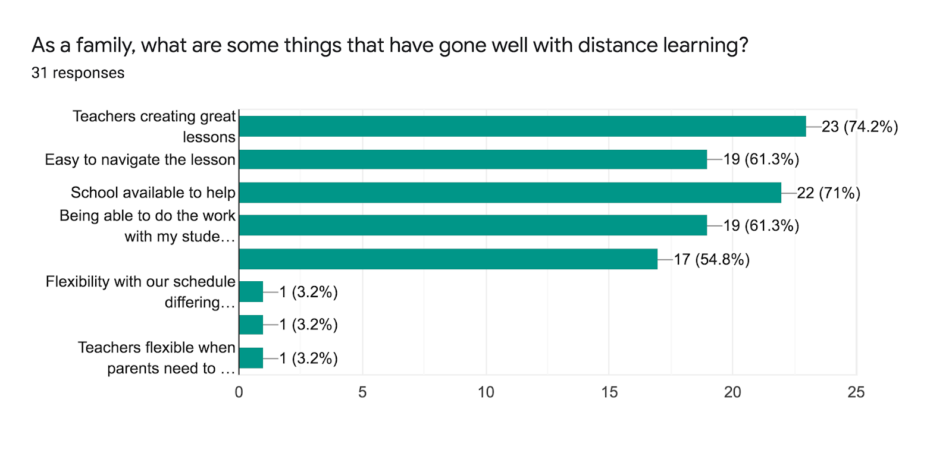

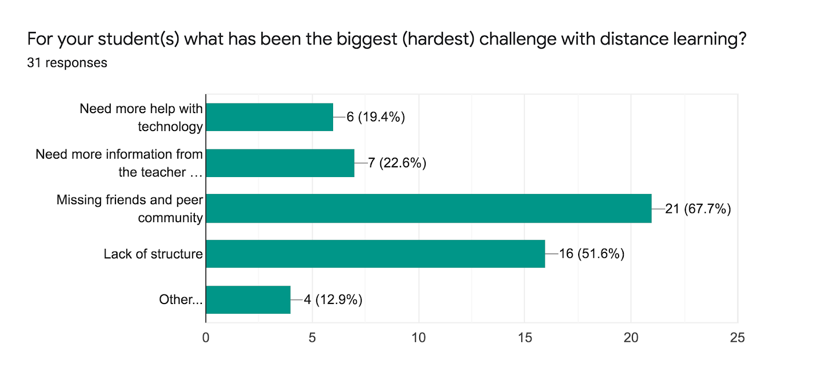

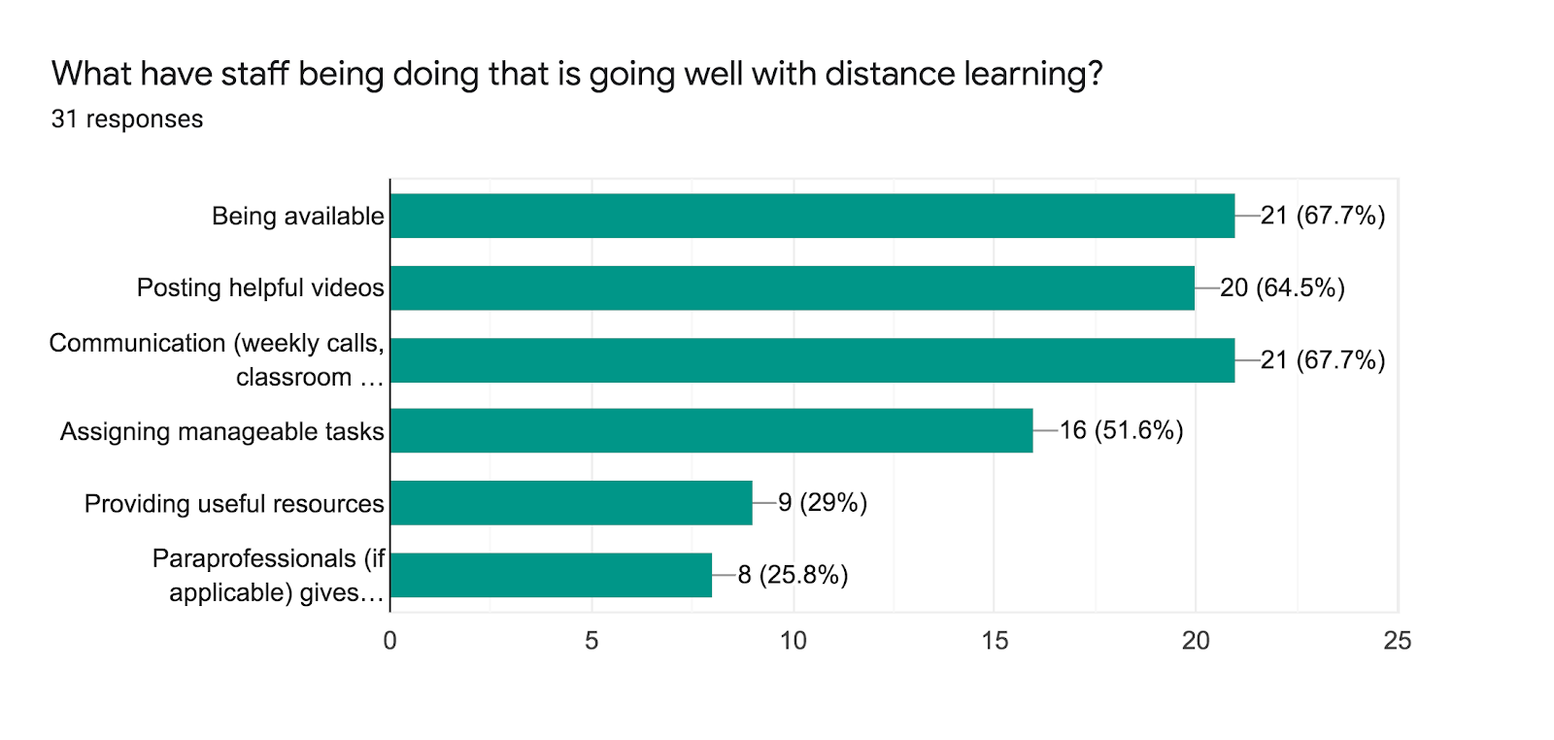

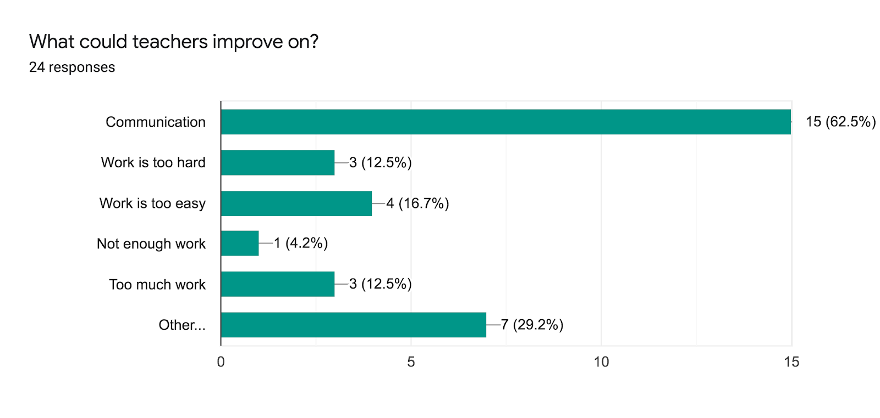

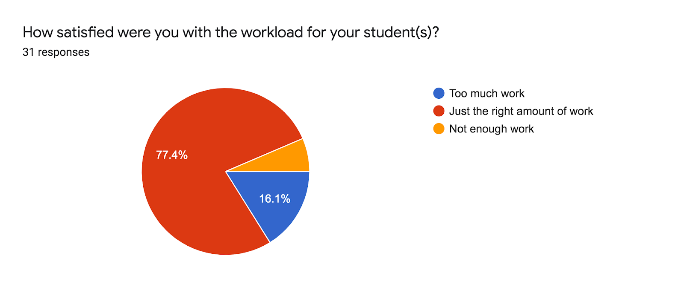

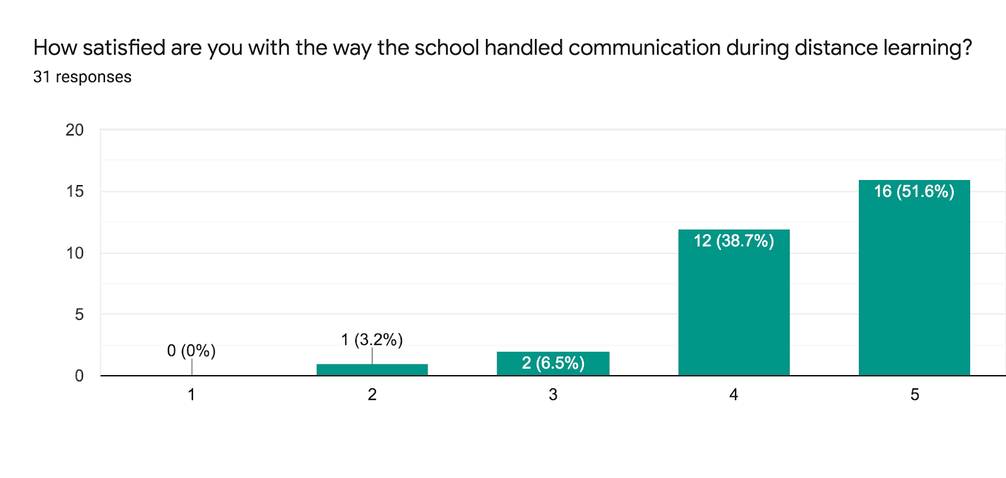
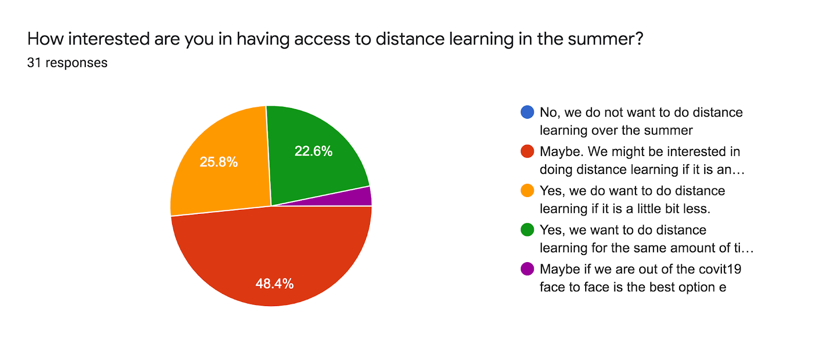

XII. Innovative Practices

We believe that our combination of programs (International Baccalaureate, Responsive Classroom, ENVoY, Talent Development) is quite innovative.
Our longer school hours than the local district, more professional development hours (due to two hours every Friday afternoon and teachers returning earlier in August than most schools), and abundant teacher coaching is also innovative and aligned to what research suggests is most important for the success of schools serving a high percentage of students who qualify for free or reduced price lunch. Another innovative aspect of our school model is the language instruction and the way we offer two specialist classes daily. All of our students are learning both Arabic and Spanish, in addition to the primary language of instruction, which is English. There is a large body of research showing that exposure to a student’s native language in school enhances success in school and English language acquisition. About 25 percent of our student body’s native language is either Spanish or Arabic and another 50 percent or so get significant exposure to Arabic from a young age through their religious instruction outside of school, so our model of offering Spanish and Arabic is strongly in line with research on promoting success in school and English language acquisition in our student population.

Students in 2019-20 also had either music or art or physical education every day, ensuring that there was time for either artistic expression or physical movement each day (in addition to daily recess). Fridays were shorter days because students were dismissed at 1:30, so students rotated between the five specialist classes. Of course, all of this changed when the school closure occurred in mid-March, but once we are back to normal in-person learning, we plan to maintain these specialist offerings.

XIII. Major Accomplishments in 2018-19 and Future Plans

Accomplishments:
We had several major accomplishments in 2019-20, as cited below:
- Transfer of building ownership
  - This occurred in February 2020 and will enable a better lease, better fund balance, and pave the way for us to create an Affiliated Building Company (ABC) to own our building by summer 2021
  - This took well over a hundred hours of work from the school leadership team, but sets the school up on solid footing for many years.
- “Good to Great” Grant from Minnesota Comeback (Winter 2019 to present)
  - We applied for and received this grant in 2019. The purpose of the grant was to assist us in going from “good to great.” This process began with a school quality review funded by the grant and done by Bellwether Education. It then led to us using the school quality review to identify our top priorities to improve as a school over the next four years and a “success plan” for how to hit those top improvement priorities. It concluded with an appeal to Great Minnesota Schools for additional grant funding in order to be able to implement the “success plan” with fidelity. This appeal was successful in securing $472,000 over the next four years to implement this success plan. The grant will pay for curriculum, training, and technical supports. In 2019-20, we hit necessary benchmarks in order to receive the second year of grant funding.
- Shifting of the school model from in-person learning to distance learning in a span of a few days in mid-March 2020.
  - When schools closed in mid-March 2020, our students' families faced immediate challenges. Many lost jobs and they depended on the daily breakfast and lunch that their children received each day at school; only about 40% had adequate technology and internet access to engage in distance learning via online platforms; most were not quite sure how to adapt to distance learning. We responded quickly and decisively. In order to ensure that all families who needed those daily meals got them, we cut ties with our transportation company, who had been woefully unreliable and unsanitary, and we contracted with another company to deliver 10 meals a week to any student whose family requested them. This company temperature checks their drivers each day before they started work and sanitizes its vehicles at the end of each day. We have been delivering well over 1000 meals each week ever since the second week of school closure in March. We quickly organized, prepared, and then distributed all of the technology we had in our building and then applied for (and got) a $21,000 grant to buy additional technology. By March 25th, all students had adequate technology to engage in distance learning. In order to be responsive to families' needs throughout the COVID time, we made weekly calls to every family, asking each week if their basic needs are taken care of, if they are healthy, if their technology is still working, if their children need any particular assistance with their schoolwork, and more. Many different needs came up, including needs for basic supplies (diapers, cleaning supplies). We met those needs. Teachers adapted their instruction to an online format quickly and skillfully. They learned from each other and steadily got better each week at creating online lessons.
  - Based on family feedback, we put together a summer school in about two weeks at the end of the school year. Families expressed that they wanted to continue their children’s learning over the summer. About 140 students attended and the focus was on literacy.

Future Plans:

One of our major future projects is creating a more robust system of data. This system will enable us to track more easily individual student progress over time. It will also enable us, over time, to compare data from different assessments (FAST, iReady, MCA, unit and weekly assessments, etc.) to get better at predicting student performance on the MCAs and have a better sense, in real time, of whether or not a given student is performing on grade level. We have begun implementing this system by purchasing Performance Matters data management platform. We already have it up and running and we have begun comparing student performance on different assessments.

We will also be in the fourth year of our Alternative Delivery of Student Interventions Services (ADSIS) grant in 2020-21. This grant enabled us to continue to have 2 academic intervention teachers (funded by ADSIS—we have other ones not funded by ADSIS) and a full-time social worker for the 2019-20 school year. The academic intervention teachers will continue to be instrumental in helping us meet the particular academic needs of a wider range of students. Our school serves students from an incredibly diverse range of racial, cultural, socioeconomic, and linguistic, backgrounds and circumstances. Meeting the particular needs of each student is an on-going challenge. Having these academic intervention teachers will continue to greatly enhance our school’s capacity to meet all of their needs. The social worker will provide leadership and support in meeting social and behavioral needs for our students. He will also assist our student’s families in accessing needed resources outside of our school.

A major plan on the horizon soon will be expanding into the lower level of our new building. That plan is on hold for now, though. During the summer of 2020, we completed major improvements of our cafeteria and middle school space, enabling our middle school to exist in a much more self-contained way than before. Because of these projects, currently we have enough space to house our program for several more years and we will not need to expand into the lower level of our building soon. This represents a huge savings in time, money, and resources.

XIV. Northeast College Prep: Continuous Improvement Plan 2020-21
Northeast College Prep is implementing many different measures in the upcoming 2020-21 school year to continue our process of improvement. Many of them are the same as or similar to the 2019-20 school year, as the pandemic disrupted some of the normal timelines for measuring the accomplishment of goals. Through an agreement with Great Minnesota Schools, all of the goals that were tied to our “Good to Great” grant were simply pushed back one year. So the goals have not changed from what we shared in the 2018-19 annual report, they have simply been moved back one year to account for the pandemic.

Areas of Focus for the 2020-21 School Year:
This continuous improvement plan will focus on our academic goals, which are those in our authorizer contract:
- The school will demonstrate grade level and school wide proficiency rates in math and reading that exceed those of the state of Minnesota and Minneapolis Public School District.
- The percentage of students achieving “on track” growth in math and reading will exceed the state average.
We also developed additional (and more detailed) goals through the “Good to Great” process. Through conversations with Great MN Schools, these goals were pushed back by one year due to the pandemic, so these goals are now as follows:

Academic Goals:
- MCA Math (proficiency): Over the next 4 school years (from 2020-21 through 2023-24), here are our target numbers for school-wide proficiency: 48%, 55%, 63%, 68%
- MCA Reading (proficiency): Over the next 4 school years (from 2020-21 through 2023-24), here are our target numbers for school-wide proficiency: 46%, 52%, 59%, 67%
- MCA Math (on-track growth): Over the next 4 school years (from 2020-21 through 2023-24), here are our target numbers for school-wide proficiency: 50%, 55%, 60%, 63%
- MCA Reading (on-track growth): Over the next 4 school years (from 2020-21 through 2023-24), are our target numbers for school-wide proficiency: 50%, 52%, 57%, 63%
- MCA Science (proficiency): Over the next 4 school years (from 2020-21 through 2023-24), here are our target numbers for school-wide proficiency: 34%, 40%, 46%, 53%

Student Talent Development Goals:
- Percent of students involved in a talent development opportunity: Over the next 4 school years (from 2020-21 through 2023-24), here are our target numbers: 55%, 60%, 65%, 70%
- Percent of students who increased personal areas of passion from BOY to EOY (survey data): Over the next 4 school years (from 2020-21 through 2023-24), here are our target numbers: 55%, 60%, 65%, 70%

Teacher Growth Goals:
- Percent of teachers who believe coaching support is making them a stronger teacher (survey data): Over the next 4 school years (from 2020-21 through 2023-24), here are our target numbers: 80%, 85%, 90%, 90%

The role of the board in the continuous improvement plan:
Our strategic planning process also resulted in several actions taken on the part of the board to strengthen oversight of the school’s pursuit of charter contract goals. One such action was to create an Academic Committee to monitor the school’s progress toward the annual academic goals. This group met quarterly during the 2019-20 school year prior to the pandemic to review interim assessment data, monitor progress, and ensure that the Director is accountable for academic outcomes. In the 2020-21 school year, the Academic Committee is planning to meet even more frequently. The Governance Committee, another outcome of the strategic planning process, made great strides last school year to align the Director evaluation to the annual and interim academic goals. This work done by these committees, along with the work by the administrative team, is ensuring that there are clear lines of accountability from the board to the Director, through the administrative team, and down to the teachers, so that no student falls through the cracks.

XV. Authorizer Contact Information

If you would like to contact Northeast College Prep’s authorizer directly, you may contact Liz Wynne, Executive Director of Student Achievement Minnesota, at:

Student Achievement Minnesota
P.O. Box 581639
Minneapolis, MN 55458-1639
liz.wynne2@gmail.com
http://www.samnllc.org/contact-us

